Homework: Databases
Problems for homework for the "Software Technologies" course @ Software University
Submit this document as your homework

Address Database
- CREATE DATABASE named `address_database` and USE it:
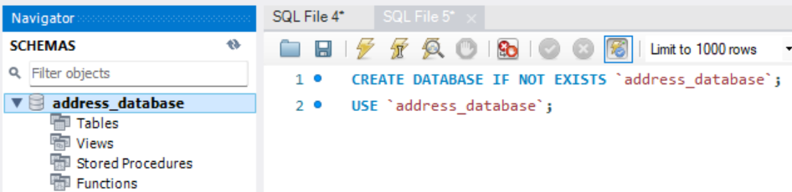

- CREATE TABLE named `addresses` with the following columns:
  - street_number
  - street_name
  - area
  - town
  - district
  - country
  - continent
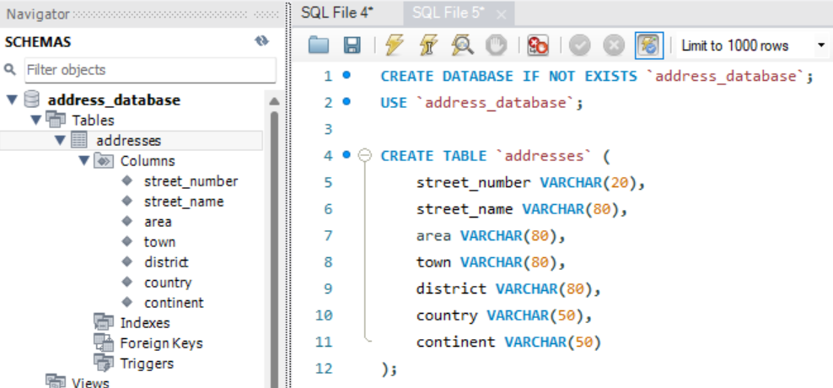

- We forgot to add Boolean column, named `isCapital`:
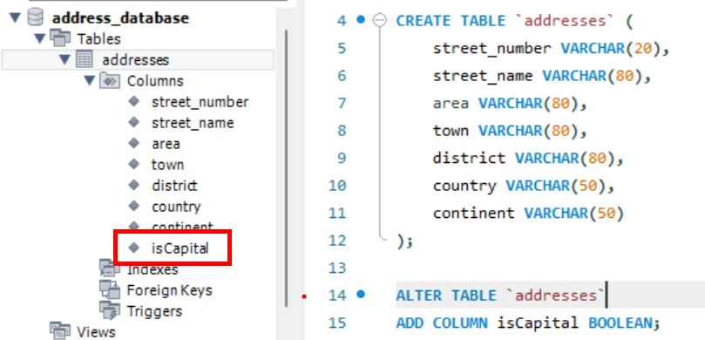

- INSERT records INTO the `address` table and execute the SQL query:
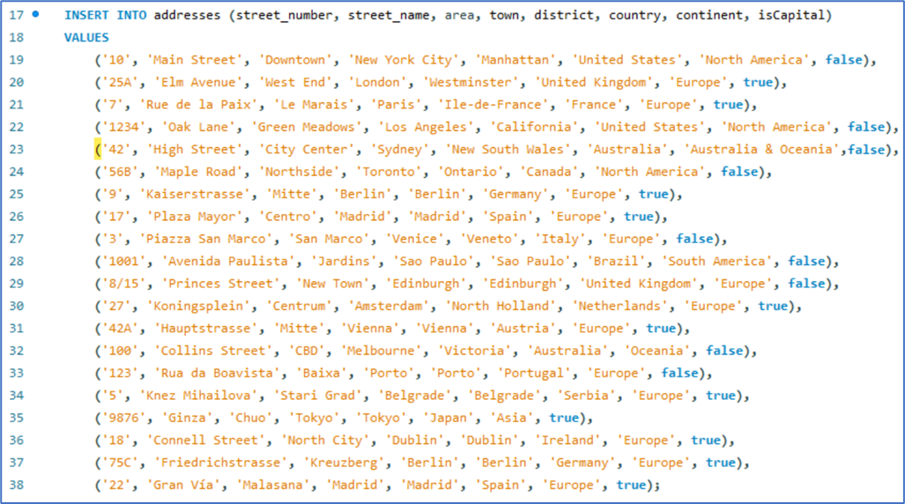

- Your task is to execute the proper queries in order to get the following results:
  - SELECT all addresses from the `address` table that are located in a capital city.
  - SELECT all addresses from the `address` table that are located in South America.
  - SELECT all addresses from the `address` table that are located in Europe, but only in NON Capital cities.

- Create queries for each condition and place a screenshot after each query !
- 1. SELECT * FROM address_database.addresses;
- 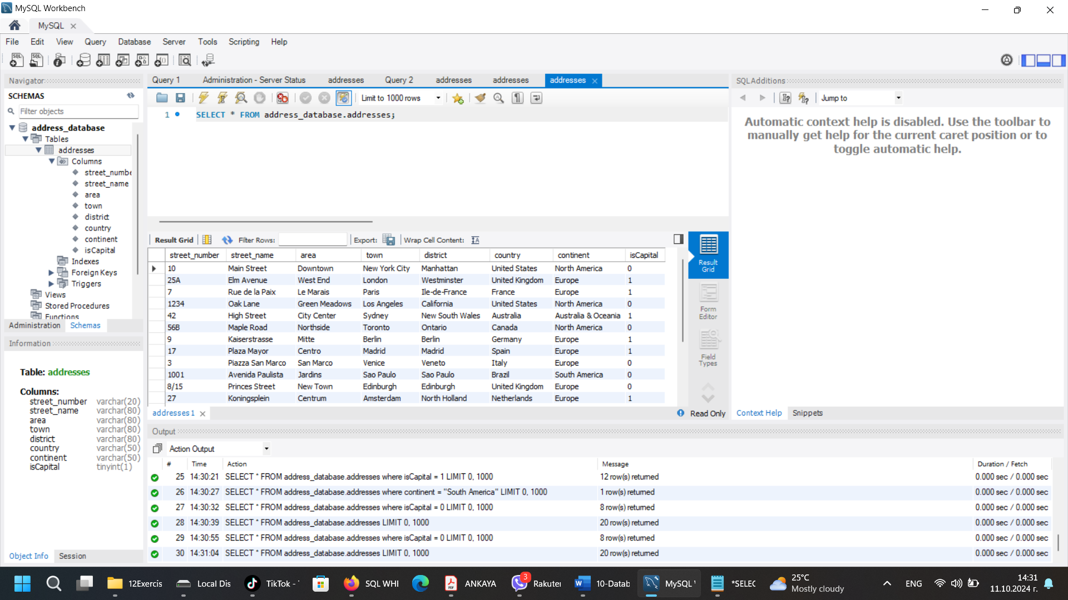
- 2. SELECT * FROM address_database.addresses where isCapital = 1; # Capital
- 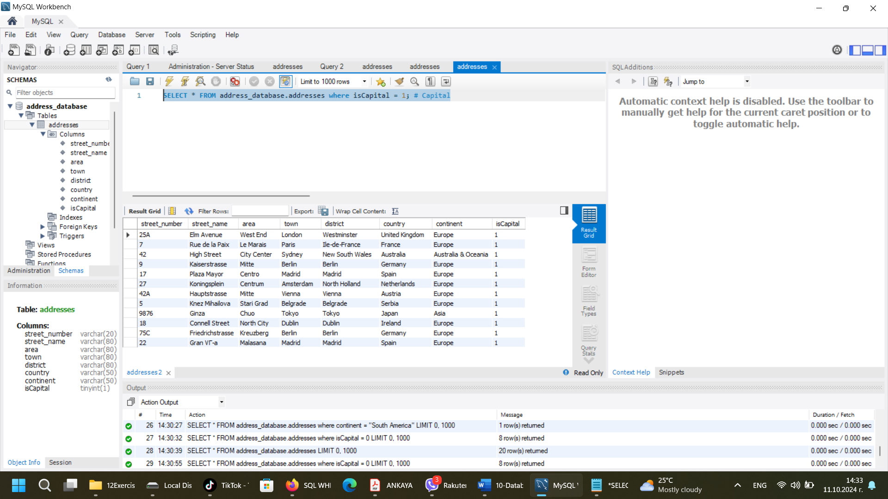
- 3. SELECT * FROM address_database.addresses where continent = "South America"; #South America
- 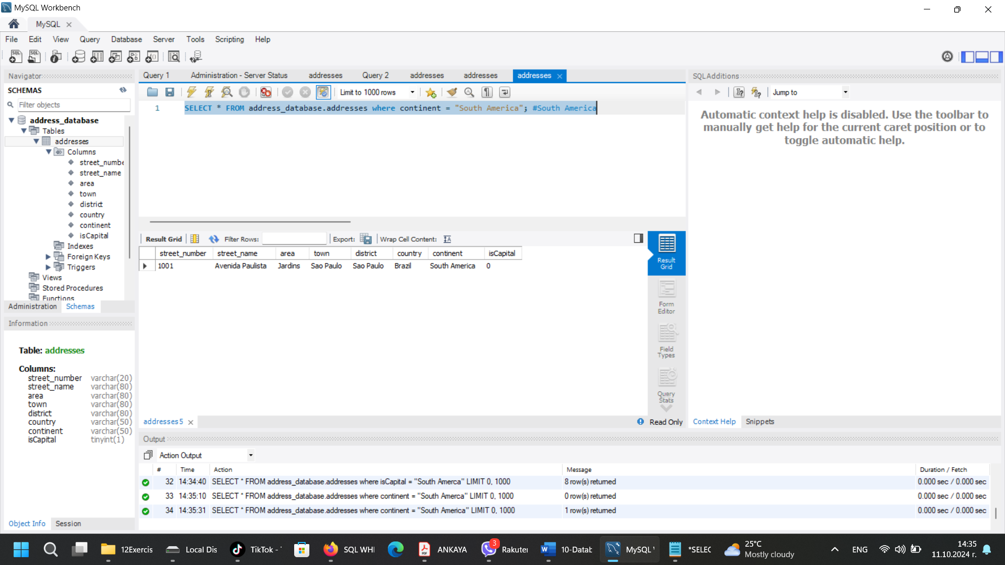

4. SELECT * FROM address_database.addresses where continent = "Europe" AND isCapital = 0; #Only Europe and Non capitals
